Creating a new database.

- You can use any of the following methods.
- Click your mouse on the File menu on the menu bar in the left hand corner. Select New.
- Click your mouse on the New tool (it is the leftmost tool on the toolbar; it looks like a blank sheet of paper).
- Press CTRL+N.
- Next, you will see the new side menu that appears in the right hand side as shown in Figure 1-1.
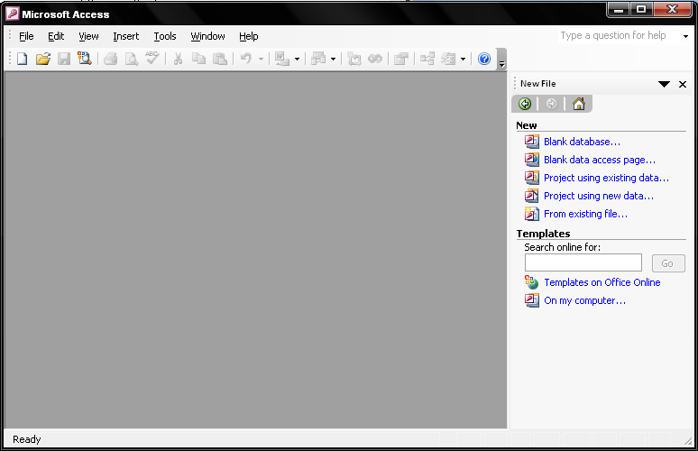
Figure 1-1
- Choose Blank database on that side menu. Then, Access displays the File New Database dialog box, as shown in Figure 1-2.
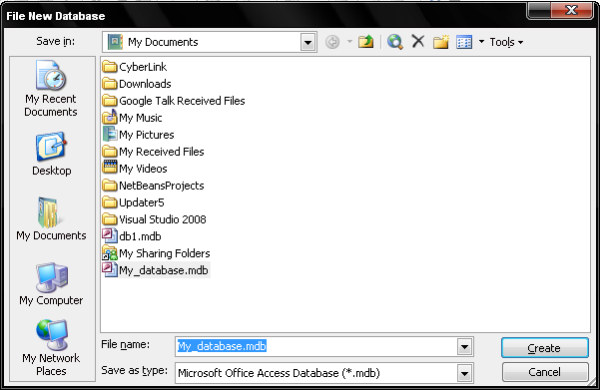
Figure 1-2
To save, the File New Database dialog box, just specify the name you want to use for your database and where you want to store the database. Now click on Create button.

- Access creates the new database, using the name you provided, and displays the Database window shown in Figure 1-3. Notice that the name of your database is shown at the top of the Database window.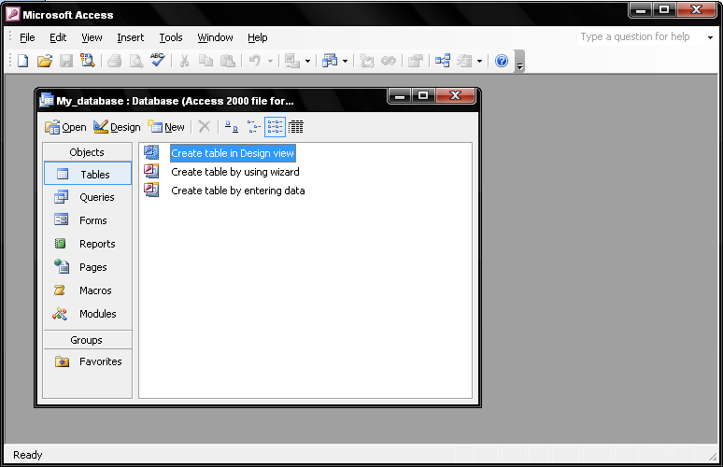
Fugire 1-3
Since this Database window is for a brand new database, there are no tables listed. In the following section, you will learn how to create a table.

Create table in Design view

- In this method, after selecting the Create table in Design view option, Access will display a Table window as shown below in figure 1-4.
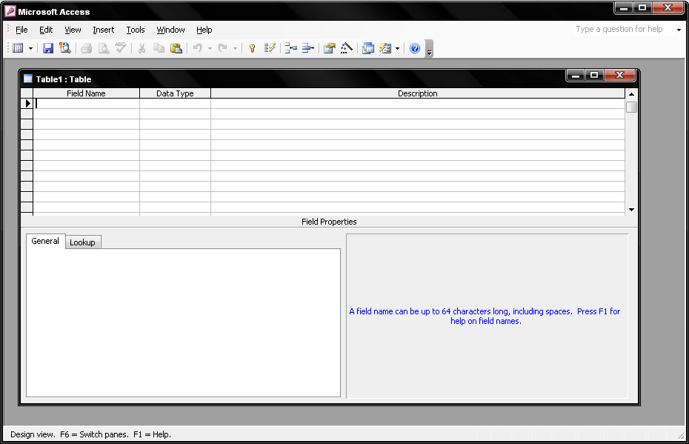
Figure 1-4
Design View will allow you to define the fields in the table before adding any data to the datasheet. The window is divided into two parts: a top pane for entering the field name, data type, and an option description of the field, and a bottom pane for specifying field properties.
- Field Name - This is the name of the field and should represent the contents of the field such as "Name", "Address", "Final Grade", etc. The name cannot exceed 64 characters in length and may include spaces.
- Data Type is the type of value that will be entered into the fields.
  - Text - The default type, text type allows any combination of letters and numbers up to a maximum of 255 characters per field record.
  - Memo - A text type that stores up to 64,000 characters.
  - Number - Any number can be stored.
  - Date/Time - A date, time, or combination of both.
  - Currency - Monetary values that can be set up to automatically include a dollar sign ($) and correct decimal and comma positions.
  - AutoNumber - When a new record is created, Access will automatically assign a unique integer to the record in this field. From the General options, select Increment if the numbers should be assigned in order or random if any random number should be chosen. Since every record in a datasheet must include at least one field that distinguishes it from all others, this is a useful data type to use if the existing data will not produce such values.
  - Yes/No - Use this option for True/False, Yes/No, On/Off, or other values that must be only one of two.
  - OLE Object - An OLE (Object Linking and Embedding) object is a sound, picture, or other object such as a Word document or Excel spreadsheet that is created in another program. Use this data type to embed an OLE object or link to the object in the database.
  - Hyperlink - A hyperlink will link to an Internet or Intranet site, or another location in the database. The data consists of up to four parts each separated by the pound sign (#): DisplayText#Address#SubAddress#ScreenTip. The Address is the only required part of the string. Examples:
Internet hyperlink example: | FGCU Home Page#http://www.fgcu.edu#
Database link example: | #c:\My Documents\database.mdb#MyTable
- Description (optional) - Enter a brief description of what the contents of the field are.
- Field Properties - Select any pertinent properties for the field from the bottom pane.
Field Properties
Properties for each field are set from the bottom pane of the Design View window.
- Field Size is used to set the number of characters needed in a text or number field. The default field size for the text type is 50 characters. If the records in the field will only have two or three characters, you can change the size of the field to save disk space or prevent entry errors by limiting the number of characters allowed. Likewise, if the field will require more than 50 characters, enter a number up to 255. The field size is set in exact characters for Text type, but options are given for numbers:
  - Byte - Positive integers between 1 and 255
  - Integer - Positive and negative integers between -32,768 and 32,768
  - Long Integer (default) - Larger positive and negative integers between -2 billion and 2 billion.
  - Single - Single-precision floating-point number
  - Double - Double-precision floating-point number
  - Decimal - Allows for Precision and Scale property control
- Format conforms the data in the field to the same format when it is entered into the datasheet. For text and memo fields, this property has two parts that are separated by a semicolon. The first part of the property is used to apply to the field and the second applies to empty fields.
- Indexes allow Access to query and sort records faster. To set an indexed field, select a field that is commonly searched and change the Indexed property to Yes (Duplicates OK) if multiple entries of the same data value are allowed or Yes (No Duplicates) to prevent duplicates.
- Field Validation Rules specify requirements (change word) for the data entered in the worksheet. A customized message can be displayed to the user when data that violates the rule setting is entered. Click the expression builder ("...") button at the end of the Validation Rule box to write the validation rule. Examples of field validation rules include <> 0 to not allow zero values in the record, and??? To only all data strings three characters in length.
- Input Mask controls the value of a record and sets it in a specific format. They are similar to the Format property, but instead display the format on the datasheet before the data is entered. For example, a telephone number field can formatted with an input mask to accept ten digits that are automatically formatted as "(555) 123-4567".

- Once the field names are entered into the table for the Event table, it will look as shown below in figure 1-5.
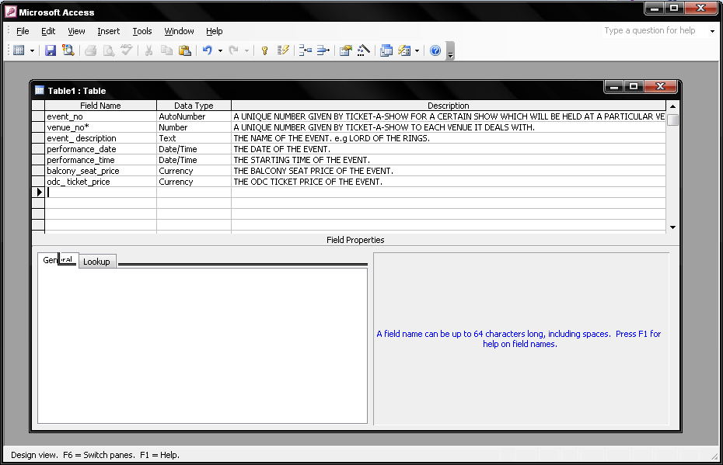
Figure 1-5

- Once all the details are entered, the table should be saves. But before that a unique field called the Primary key should be given for the table.

Primary Key
Every record in a table must have a primary key that differentiates it from every other record in the table. In some cases, it is only necessary to designate an existing field as the primary key if you are certain that every record in the table will have a different value for that particular field. A social security number is an example of a record whose values will only appear once in a database table.
Designate the primary key field by right-clicking on the record and selection Primary Key from the shortcut menu or select Edit|Primary Key from the menu bar. The primary key field will be noted with a key image to the left. To remove a primary key, repeat one of these steps.
If none of the existing fields in the table will produce unique values for every record, a separate field must be added. Access will prompt you to create this type of field at the beginning of the table the first time you save the table and a primary key field has not been assigned. The field is named "ID" and the data type is "autonumber". Since this extra field serves no purpose to you as the user, the autonumber type automatically updates whenever a record is added so there is no extra work on your part.

- In this case the event_no field can be taken as the Primary key, because it holds a unique value for each and every record.
- Then, click on the Save button on the menu bar, or select Save in the File menu to save the table created.
Then a small combo box will be prompt to enter the name for the table. (After clicking ok, you can see the name you entered appear on the task bar of the table window)
- Once you close the table window, will be able to see the name of the table appear in the database window as shown in figure 1-6 below.
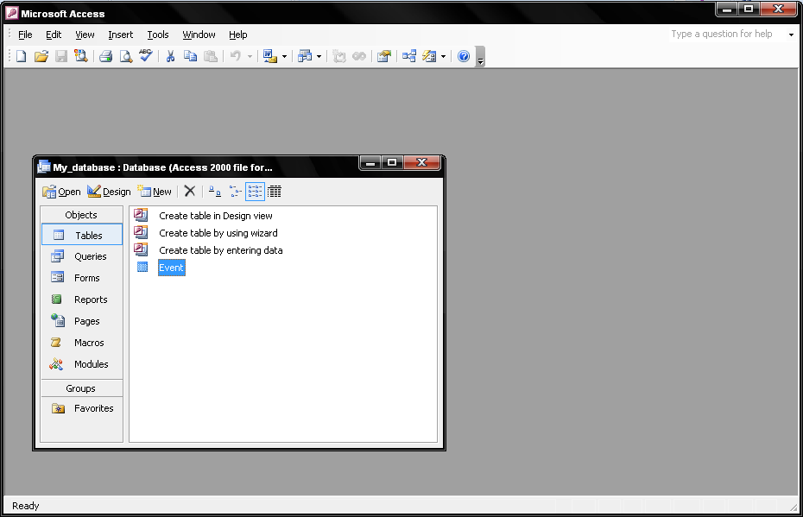
Figure 1-6

- Double click on the table you created and then start populating the table with the data required. (Showed in the figure 1-7 below)
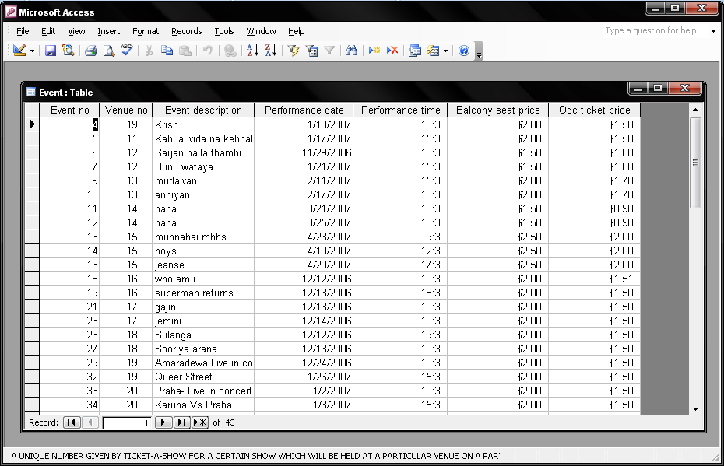
Figure 1-7

Create a form in design view

A Form gives a more user friendly method to access or view data in a database.

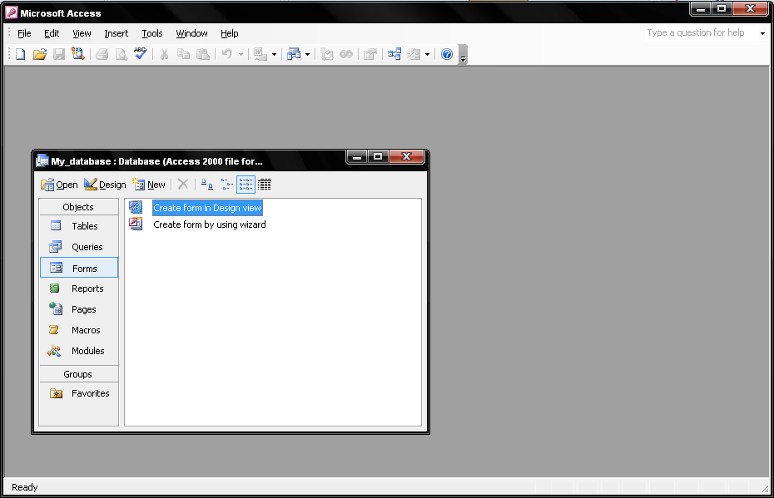
Figure 1-8
- Click the New button on the form database window. (figure 1-8)
- Select "Design View" and choose the table or query the form will be associated with the form from the drop-down menu.
- Select View|Toolbox from the menu bar to view the floating toolbar with additional options.

- Add controls to the form by clicking and dragging the field names from the Field List floating window. Access creates a text box for the value and label for the field name when this action is accomplished. To add controls for all of the fields in the Field List, double-click the Field List window's title bar and drag all of the highlighted fields to the form. (figure 1-9)

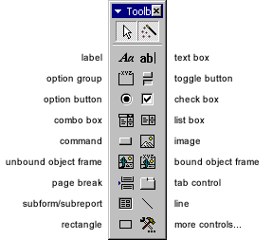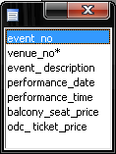
- Once the form is designed in the way you want, close the window and double click on the form that is created on the database window. Below is a sample design of the form created. (figure1-10 )

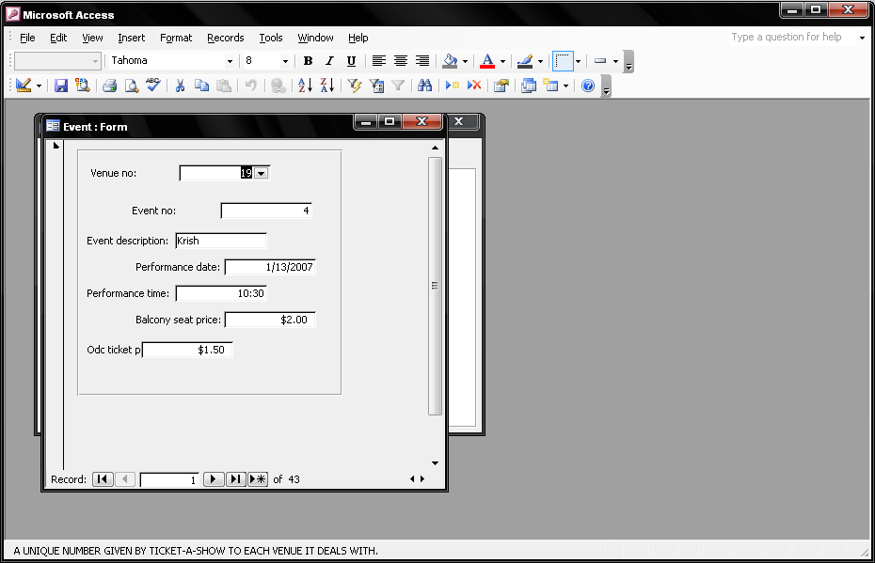
Figure 1-10

- Adding Records Using A Form
Input data into the table by filling out the fields of the form. Press the Tab key to move from field to field and create a new record by clicking Tab after the last field of the last record. A new record can also be created at any time by clicking the New Record button at the bottom of the form window. Records are automatically saved as they are entered so no additional manual saving needs to be executed.
- Following are some other facts that are important in editing forms.

- Grid lines - By default, a series of lines and dots underlay the form in Design View so form elements can be easily aligned. To toggle this feature on and off select View|Grid from the menu bar.
- Snap to Grid - Select Format|Snap to Grid to align form objects with the grid to allow easy alignment of form objects or uncheck this feature to allow objects to float freely between the grid lines and dots.
- Resizing Objects - Form objects can be resized by clicking and dragging the handles on the edges and corners of the element with the mouse.
- Change form object type - To easily change the type of form object without having to create a new one, right click on the object with the mouse and select Change To and select an available object type from the list.
- Label/object alignment - Each form object and its corresponding label are bounded and will move together when either one is moved with the mouse. However, to change the position of the object and label in relation to each other (to move the label closer to a text box, for example), click and drag the large handle at the top, left corner of the object or label.
• Tab order - Alter the tab order of the objects on the form by selecting View|Tab Order... from the menu bar. Click the gray box before the row you would like to change in the tab order, drag it to a new location, and release the mouse button.

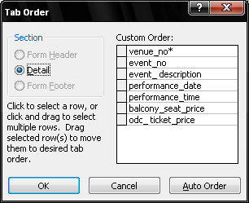

- Form Appearance - Change the background color of the form by clicking the Fill/Back Color button on the formatting toolbar and click one of the color swatches on the palette. Change the color of individual form objects by highlighting one and selecting a color from the Font/Fore Color palette on the formatting toolbar. The font and size, font effect, font alignment, border around each object, the border width, and a special effect can also be modified using the formatting toolbar:

- List and Combo Boxes
If there are small, finite number of values for a certain field on a form, using combo or list boxes may be a quicker and easier way of entering data. These two control types differ in the number of values they display. List values are all displayed while the combo box values are not displayed until the arrow button is clicked to open it as shown in these examples:
Combo Box | List Box
By using a combo or list box, the name of the academic building does not need to be typed for every record. Instead, it simply needs to be selected from the list. Follow these steps to add a list or combo box to a form:
- Open the form in Design View.
- Select View|Toolbox to view the toolbox and make sure the "Control Wizards" button is pressed in.
- Click the list or combo box tool button and draw the outline on the form. The combo box wizard dialog box will appear.
- Select the source type for the list or combo box values and click Next >.
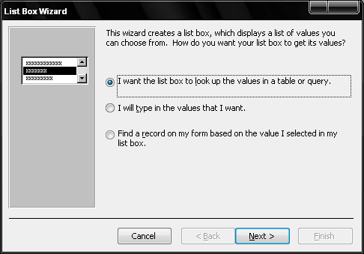
- Depending on your choice in the first dialog box, the next options will vary. If you chose to look up values from a table or query, the following box will be displayed. Select the table or query from which the values of the combo box will come from. Click Next > and choose fields from the table or query that was selected. Click Next > to proceed.
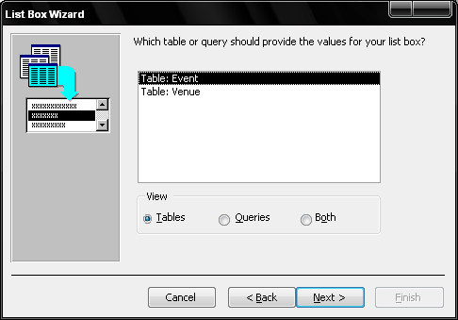
- On the next dialog box, select the fields you want to include in your list box.
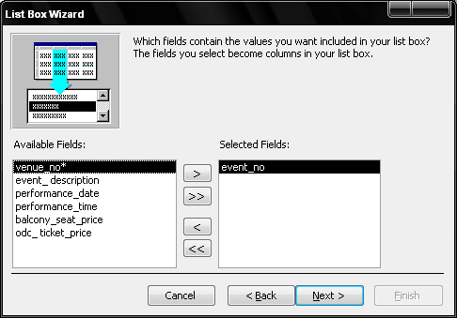
- Set the order of the fields that should appear in the list.
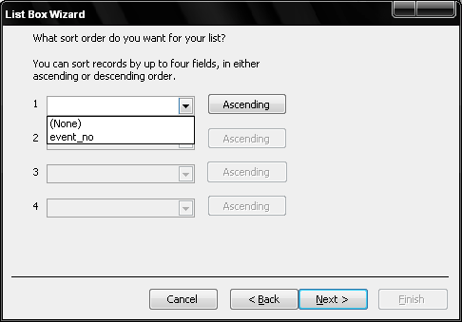
- On the next dialog box, set the width of the combo box by clicking and dragging the right edge of the column. Click Next >.
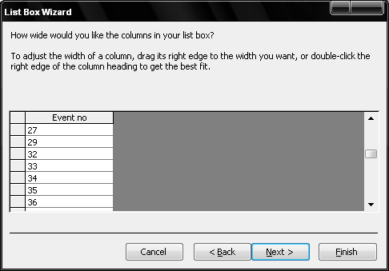
- The next dialog box allows tells Access what to do with the value that is selected. Choose "Remember the value for later use" to use the value in a macro or procedure (the value is discarded when the form is closed), or select the field that the value should be stored in. Click Next > to proceed to the final screen.
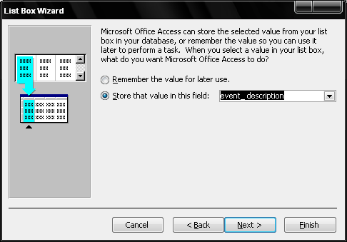
- Type the name that will appear on the box's label and click Finish.
Check Boxes and Option Buttons
Use check boxes and option buttons to display yes/no, true/false, or on/off values. Only one value from a group of option buttons can be selected while any or all values from a check box group can be chosen. Typically, these controls should be used when five or less options are available. Combo boxes or lists should be used for long lists of options. To add a checkbox or option group:
- Click the Option Group tool on the toolbox and draw the area where the group will be placed on the form with the mouse. The option group wizard dialog box will appear.
- On the first window, enter labels for the options and click the tab key to enter additional labels. Click Next > when finished typing labels.
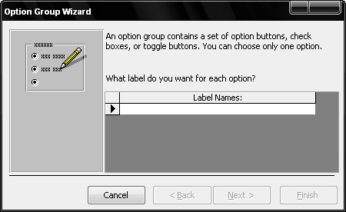
- On the next window, select a default value if there is any and click Next >.
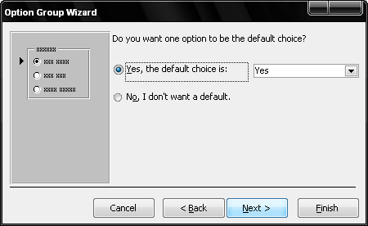
- Select values for the options and click Next >.
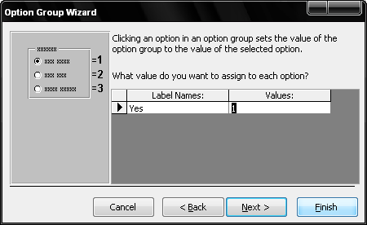
- Choose what should be done with the value and click Next >.
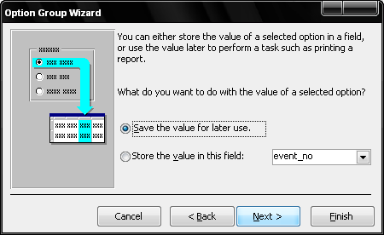
- Choose the type and style of the option group and click Next >.
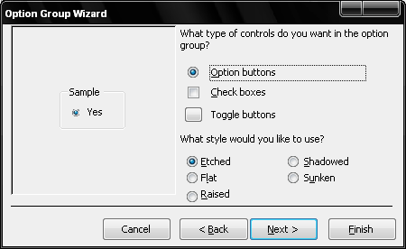
- Type the caption for the option group and click Finish.

